Suppose you have having imbalance dataset. What will be the strategies that you can use to balance it.

Data Imbalance usually reflects an unequal distribution of classes with in a dataset. For example, in credit card fraud detection dataset most of the credit card transactions are not fraud and very few classes are fraud transactions. When dealing with an imbalance dataset where one class significantly out numbers the others its crucial to address the imbalance before training your model. Otherwise, your model might get biased towards the majority class and perform poorly on the minority class, leading to misleading results. Here are some strategies you can use to balance your dataset

Oversampling; This involve creating synthetic data point for the minority class. Techniques like SMOTE (Synthetic Minority Oversampling Technique) create new data points based on existing minority class examples in the feature space. While effective, oversampling can lead to overfitting if not done carefully.

Under sampling; This involve randomly removing data points from the majority class to reduce its size and match the size of the minority class. However, under sampling can discard valuable information from the majority class.

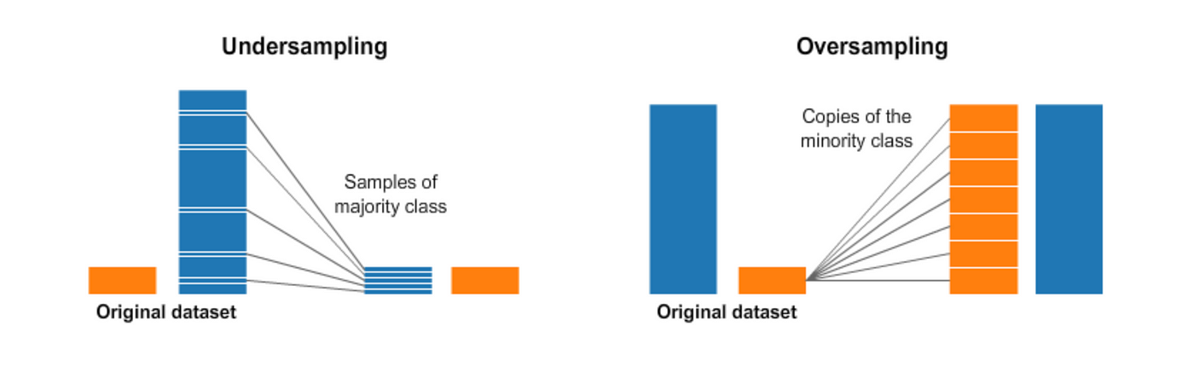

Cost-sensitive learning; Assign higher weights to misclassifications of the minority class to penalize the model for mistakes on the less frequent examples.

Ensemble methods; Combining multiple models trained on different subsets of the data can improve performance on imbalanced problems. Techniques like Random Forest and Gradient Boosting can be effective.

Thresholding; Instead of focusing on accuracy, adjust the decision threshold to prioritize identifying the minority class correctly, even if it sacrifices some accuracy for the majority class.

Normalization/Standardization; Normalize or standardize the features before training. This ensures all features have similar scales, preventing the model from being biased towards features with larger values, which can be common in imbalanced datasets.

Metrics beyond accuracy; Instead of relying solely on accuracy, use metrics like precision, recall, F1-score, and AUC-ROC that are more sensitive to class imbalance and provide a more complete picture of the model's performance on both classes.